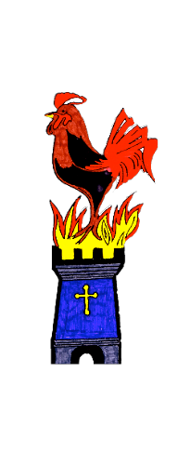

KIBBLESWORTH ACADEMY

**Help and Advice for Ordering School Uniform**



Dear Parent/Carer,

Our school uniform provider is **BE Schoolwear** which can be ordered via their online service [www.beschoolwear.co.uk](http://www.beschoolwear.co.uk).

School uniforms can be ordered direct from their website and delivered direct to your home. They have recently reduced the cost of their delivery charges and they offer free deliver on orders over £45. Please note orders for guaranteed deliver in time for return to school is **20th July** **2020**. Please visit [www.border-embroideries.co.uk/delivery-shipping/](http://www.border-embroideries.co.uk/delivery-shipping/) for more information on summer ordering and deliveries.

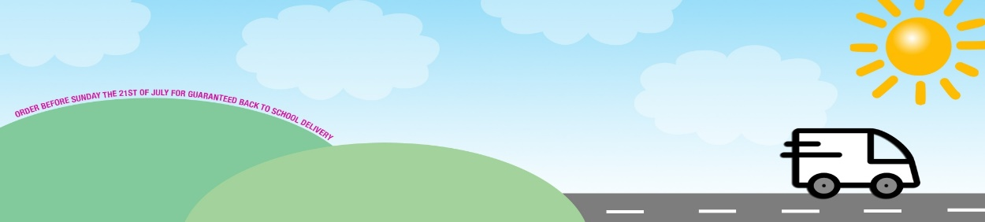

Please refer to our ‘School Uniform Requirements’ letter enclosed which lists the uniform items needed.

Kind Regards,

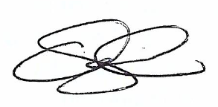

Mr Craig Steel

Head Teacher